Table of Contents

**Number of Tasks2**

**Tasks Parameters2**

**System Tick Rate3**

**Hyper-period3**

**CPU load3**

**Simso result4**

**My comments on Simso result6**

**Number of Tasks:**

There are **Five** Tasks:

* LCD Task (T1).
* Blood Pressure Sensor Task (T2).
* Heart Beat Sensor Task (T3).
* Temperature Sensor Task (T4).
* Alert Siren Task (T5).

**Tasks Parameters:**

* T1 🡪 { P : 100 , E : 2 , D : 100 , PRIORITY : 1 } .
* T2 🡪 { P : 12.5 , E : 3 , D : 12.5 , PRIORITY : 2 } .
* T3 🡪 { P : 50 , E : 1.5 , D : 100 , PRIORITY : 2 } .
* T4 🡪 { P : 10 , E : 2 .5, D : 10 , PRIORITY : 2 } .
* T5 🡪 { P : 10 , E : 1 , D : 10 , PRIORITY : 3 } .

**System Tick Rate:**

The Total execution time for the entire tasks is 10ms, hence the Tick Rate is **15ms**.

**Hyperperiod:**

H **= 100 ms.**

**CPU Load:**

U = R/C = (2+ (3*8) + (1.5*2) + (2.5*10) +10)/100 = 0.64

CPU Load is **64%.**

**SIMSO Results:**

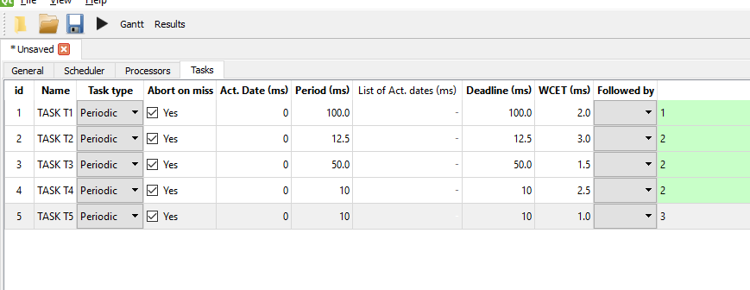 **Tasks Parameters:**

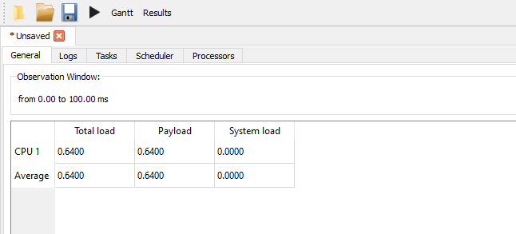**CPU load:**

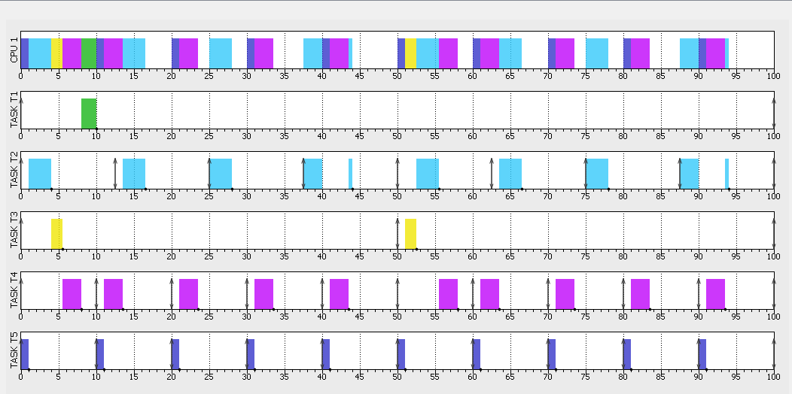**Time Line:**

**Comments on SIMSO results:**

There is no task missed its deadline ,hence the system is schedulable and feasible.

The CPU load is the same as the CPU load manually calculated .